Adhikar Chhibber
Yurui Huang

Predicting the Outcome of Chess Matches Based on the Opening

Introduction.

Chess is a board game in which two players take command of two armies: black and white. Each side takes turns commanding one piece in their army to not only put the enemy king in their line of sight, but also to ensure the enemy king cannot move, thus resulting in a win known as a “checkmate”. This board game has a finite amount of moves and board states from which we could theoretically analyze to determine who has the advantage at a given time. However, the start of the match is what we call the opening. The definition of how many moves does this opening cover is a topic that is up for debate but the usual range given is six to ten moves (do note that a single move consists of both players taking a turn). This opening is generally considered to be extremely important as it can define the tempo of the match and in some cases, the winner.
Our goal in this project is to make a custom machine learning architecture that is capable of predicting the winner of a chess match solely based on the opening. In this project, we are defining the opening to be the first eight moves (we also include the initial board state as well but we do not count this as a move since all games have this initial state) as it is the middle between six and ten moves.
The idea behind making such a machine learning model to predict the winner is not only to simply make a winner predictor, but to also gauge the importance of the opening by the model’s performance. If a model is simply predicting at an accuracy of fifty percent then it is doing no better than a coin toss. In which case we can say that if our model cannot do better than a coin toss then it suggests that the opening of a chess match cannot be a reliable indicator of a winner. If the model does worse than fifty percent then we can say that the opening may not be as important since we cannot reliably predict the winner. If the model is over fifty percent (ideally we want to make a model that can have a validation accuracy of at least sixty percent), then we can say the opening may be important as we can reliably predict the winner of a chess match.
In short, we wish to not only make a predictor model to analyze the openings of a chess match, but we also want to see if we can also judge openings in general based on the model’s performance and the overall idea if an opening is important.

Related Work.

There has been some work done in making such predictor models, however they do not specifically use just openings as they simply build a model capable of handling long sequences and the hope is just to have a model (or do feature engineering) to allow a pre-existing model to become a predictor.
One such paper actually utilized a variety of features to showcase the performance of the naive bayes classifier. The paper “Statistical Analysis on Result Prediction in Chess” utilized several features such as the stockfish evaluation, move sequence, opening classification, and even the move list to determine the winner of a match. This paper used ten thousand games in which they derived several things. Firstly is the stockfish evaluation of each board state in the game. Stockfish is a powerful chess engine that is capable of giving an evaluation of the board on who is in the advantageous position given the board state. This evaluation has a parameter known as depth which tells the engine to look a certain amount of board states ahead in making this evaluation. In this paper they chose a depth of 17 which means they are looking at 17 moves in the future game tree to determine the evaluation score (or rather they are using stockfish to do so). This paper also used ECO which actually is a classification for the opening that was played in the game. Using this and the other features, they then used the naive bayes classifier to do the predictions. They did use sequences of ten, fifteen, and twenty in their analysis and prediction. The highest accuracy they achieved was almost sixty seven percent when the model was given a twenty move sequence and given almost all features (it seemed as though giving all features actually overwhelmed the model and made it perform worse.) This sort of performance became our benchmark as we wished to aim for an accuracy over sixty percent.
Another paper that also attempts to make a predictor but this one uses LSTM (Long Short term Memory). The overall idea in this paper was to utilize LSTM to process the chess game alongside another dense layer network to process the overall content of the game itself. The content they are looking at is the rating of both players, and when and how the match took place. They represent the chessboard in an algebraic manner and as a bitmap as well. To prevent overfitting, they trained the model for a short amount of time (five epochs) and they just save the best model. They also process sequences in amounts of twenty, fifty, and eighty (this corresponds to ten moves, twenty five moves, and forty moves which is usually the whole match). Their overall results is about a sixty nine percent accuracy on a model that takes the match as a bitmap and they process a sequence of 80 (forty moves). This showcases the model does have potential but using the LSTM seems to provoke overfitting in the model so training such a model would be quick but won’t generalize well with more epochs.

Technical Approach: Data preprocessing

Our project will use chess matches from database.lichess.org which is a website that stores lots of games from each month of each year. They store the chess data in PGN format that is also zipped. We specifically will be using the dataset from March 2015 as when it is uncompressed, we get about 1.7 gigabytes of data (about a million games).
Before we process the data, we want to first ensure that we only take highly rated games. This mostly guarantees us that we will have high quality openings in the data as highly skilled players are more likely to stick to certain openings or patterns that we will hopefully be able to take advantage of.
To first process the data, we need to take every game and gather the first 8 moves in each game. Then we convert each move into a FEN (Forsyth-Edwards Notation) which is a way to represent the full board when a move has been made. Then with this FEN, we now convert it to a tensor for us to use so now we have in each game about 17 tensors (we add one additional tensor to represent the initial board before any move has been made).
For each FEN then, we will utilize stockfish to give an evaluation of the board. Originally we had chosen to use depth 17 as the related works however this proved to be computationally difficult on our hardware as the estimated time to convert all the games we had was about several days. Due to this, we reduced our dataset down to 100 thousand games and reduced the depth down to 8 as this gave us a reasonable time to process which was now only about 10 hours.
Finally with our evaluations, the tensors for each game, we also included some meta data from the game. This primarily includes the ratings of both players who were playing the game at the time. We then save this to a pickle file which better stores the tensors while keeping the same pandas dataframe format which we are mainly accustomed to.

Technical Approach Model 1.

For our first model architecture, we decided to use a combination of a convolutional neural network (CNN) and a recurrent neural network (RNN) then a final multi-layer perception (MLP) to perform our classification. The main reasoning behind this model is that the CNN will first get the tensors that represent the board. This acts like a batch of images we are trying to understand, then we attach the evaluations to this and plug this into the RNN so the model now understands the images and their associated board evaluations in a sequence (these evaluations are normalized before they are used as input). Then the final MLP will allow us to perform the classification we desire.
We will first detail the CNN portion of this model. The first CNN layer has a kernel of 3 and padding of 1 and our in channels are 12 and our out channels are defined at 32. We then utilize GELU activation functions before performing another CNN layer with similar parameters except our in channels is 32 and our out channels are 64. When then perform another GELU activation function then finally we flatten the result.
We then concatenate the result of the CNN to the evaluations we computed earlier and then input them into the RNN which is defined as GRU (Gated Recurrent Unit). The parameters we chose to modify for the GRU would be that we set batch_first to true and our hidden size is 256.
Finally we pass in the result of the RNN to our MLP which has a linear layer to reduce down to 128 dimensions then we use GELU activation function again then a final linear layer which performs our final classification as the output is of size 2 (white or black).
To train this model, we utilize cross entropy loss and the adams optimizer. For this model, we do also use a learning rate scheduler to adjust the learning rate mid training. This was used to try and stave off the effects of overfitting. This model also was trained with the strategy of early stopping so we save the best model we get from any of our training loops.

Technical Approach Model 2.

While the first model showed great potential in predicting the winner of a given board based on opening moves, it still has some limitations. If two distinct players have a big ELO gap but played into the same opening, the outcome still heavily favors the stronger player. In this model architecture, we redesigned the pipeline to predict the winner of a chess game not only purely on the player's performance during the opening phase but also including players’ ELO rating in order to give a more solid and reliable prediction.
The main idea is to complement move based visual features with player level context, specifically the ELO rating gaps between both players. We extract the final board state after the first 8 moves, so we can form a 12 x 8 x 8 tensor to represent its state and process it using CNN, which consists of two convolutional layers to capture the spatial features of both players’ characters. After the CNN layer, we can get a 4096-dimensional feature vector that captures spatial and positional features of the board. After we mapped the spatial information onto the vector, we can concatenate a single scalar feature: the normalized ELO difference. Which is equal to (white_elo - black_elo) / 1000. We will end up with a vector that has 4097 dimensions, which consists of the spatial information and players’ rank rating gap. Then we can perform a regular forward propagation into a three layer MLP. It has two hidden layers consisting of 256 and 128 units respectively, followed by a final linear layer producing logits for binary classification.
The motivation behind incorporating ELO is based on the observation that purely move-based prediction can be noisy, especially when different players execute similar openings with widely varying skill levels. By including ELO, the model gains a strong prior signal about expected player strength, which significantly enhances predictive accuracy without needing deeper move sequences or recurrent networks. This approach is computationally efficient and highly interpretable, achieving a performance improvement from a random baseline of 58% to approximately 64% accuracy in early tests. It also provides guidance for future experimentation with more complex inputs, such as evaluation sequences or dynamic embeddings.
This model was trained with cross entropy loss and the adams optimizer where the learning rate 1e-4 which is a standard learning rate (we tested other learning rates and none proved to be better after multiple iterations). We then also perform early stopping on this training for this model as well to prevent overfitting.

Results.

We will first discuss the results of our first model then we will discuss the results of our second model then do a final comparison with not only these models but also the models that were created in the papers that were presented in our related works. All our results will only be in terms of accuracy as to match the related works where they also only use accuracy as the measurement of performance. Please do note that we only train with 80% of our data and our validation set is 20% to keep in line with the same strategy as our related works.
The first model achieved a max accuracy of 58.14% and this model usually trained for 40 epochs (our strategy of early stopping to save the best model in place so we can train the model for a long time to see if it overfits). Below is the graph for this model’s training performance to validation performance.
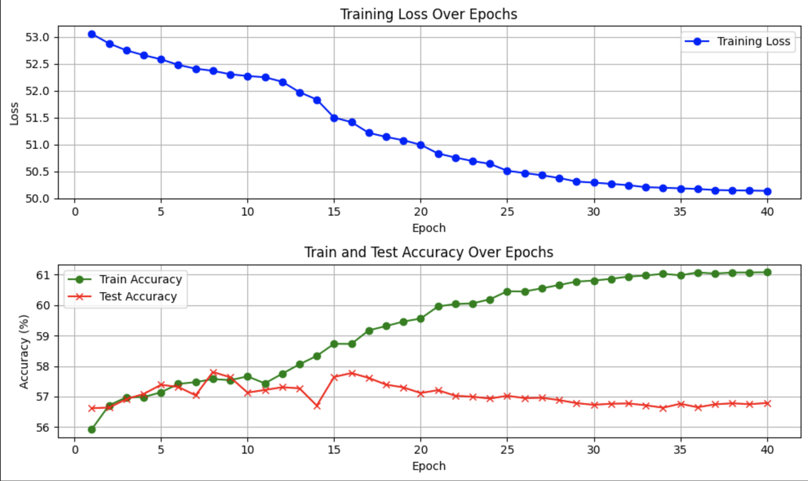

Here we see that the model’s training loss does go down over time which does showcase that the model is learning however we also see that the model’s validation performance initially grows but soon starts to drop. This is the model overfitting which we saw was common for this model. While our scheduler did in fact slow this sort of behavior down, the model will still overfit usually after 10 epochs. This is highly expected as the games we have initially are varied but since chess openings are numerous and we are in no way generalizing the opening, our model ends up getting a lot of data that may be similar to other data but differs in one way that may not affect the result but become noise in our data.
Model 2 performed far better than model with a max accuracy of 64.15% which does allow us to proclaim that we achieved our desired performance with a model (that is to gain over 60 percent in accuracy). This model’s own training was similar to model 1’s training except we did not use any learning rate scheduler. Below is the graph for the training and testing of the model.
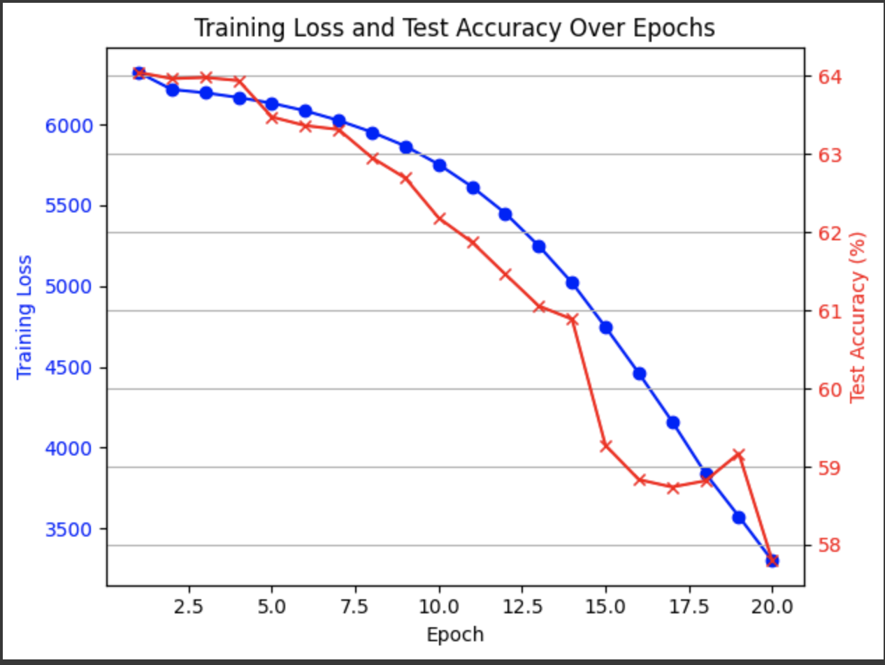
As we can see from the graph above, this model also is very prone to overfitting as after 5 epochs, we see our test accuracy start to fall with our training loss. This means that while this model did perform well, it is highly susceptible to overfitting which was a warning to us in our related works as well.

To compare both of these models to our related works, we find that our models performed surprisingly well given that we usually gave each model less data to work with and the depth of our evaluations were not as deep as the related works. We found especially with the paper utilizing naive bayes, we usually outperformed the classifier until we were comparing our performance to the performance of the classifier given 20 moves to analyze as compared to our project only using 8 moves. We also find our performance comparable with our second related work as they were only able to achieve extremely high accuracy with longer sequences as we were able to achieve a high accuracy with a much shorter sequence. Below is a final graph of both our model’s performance.
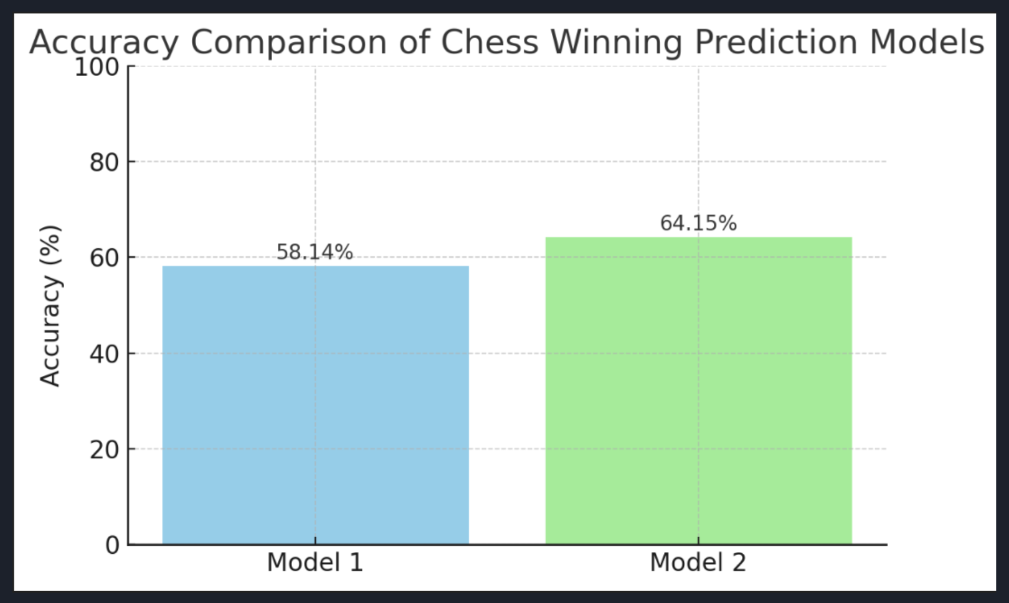

Conclusion

From this project we can conclude that we are able to create a model that is capable of accurately predicting the winner of a chess match and we are able to do so better than our original benchmark of 60%. From this we can also conclude that while the evaluation of the board states were indeed an important feature, our model performed best when we allowed it to learn that mistakes made by the lower rated player are to be treated more harshly than mistakes made by highly rated players.
Furthermore, we can conclude that openings may matter significantly as our model was able to accurately predict the winner given the opening size of 8 moves and a low evaluation consideration. We can now conclusively say that openings are an important part of chess and one attempting to become more skilled in the game must study on proper openings.
We also would like to conclude that chess openings are diverse and thus we may consider adding the ECO (opening classification found in our related works) as another feature to potentially help combat the natural noise that is a chess match. In conclusion however, we managed to complete our goal of not only creating a model with comparable accuracy to other works, but also manage to answer the question on if the opening of a chess match is important.

References.
- Lichess.org. Lichess Database: March 2015 Standard Rated Games. https://database.lichess.org/.
- Omori, Michael, and Prasad Tadepalli. “Chess Rating Estimation from Moves and Clock Times Using a CNN-LSTM.” Computers and Games, Springer Nature Switzerland, 2025, pp. 3–13.https://doi.org/10.1007/978-3-031-86585-5_1.
- David, Omid E., Nathan S. Netanyahu, and Lior Wolf. “DeepChess: End-to-End Deep Neural Network for Automatic Learning in Chess.” Artificial Neural Networks and Machine Learning – ICANN 2016, Springer International Publishing, 2016, pp. 88–96. https://doi.org/10.1007/978-3-319-44781-0_11.
- Lehana, Paras, Sudhanshu Kulshrestha, Nitin Thakur, and Pradeep Asthana. “Statistical Analysis on Result Prediction in Chess.” I.J. Information Engineering and Electronic Business, vol. 10, no. 4, 2018, pp. 25–32. https://doi.org/10.5815/ijieeb.2018.04.04.
- Dreżewski, Rafał, and Grzegorz Wątor. “Chess as Sequential Data in a Chess Match Outcome Prediction Using Deep Learning with Various Chessboard Representations.” Procedia Computer Science, vol. 192, 2021, pp. 1760–1769. Elsevier, https://doi.org/10.1016/j.procs.2021.08.180.
- Stockfish contributors. *Stockfish Chess Engine*. Version 15, 2022, stockfishchess.org.

LINK TO GOOGLE DRIVE:
https://drive.google.com/drive/folders/1koOwjXVErw5JrvrVGD2MlWTaVFqhtds9?usp=sharing

